RELATIONSHIPS AND SEX EDUCATION THERAPY
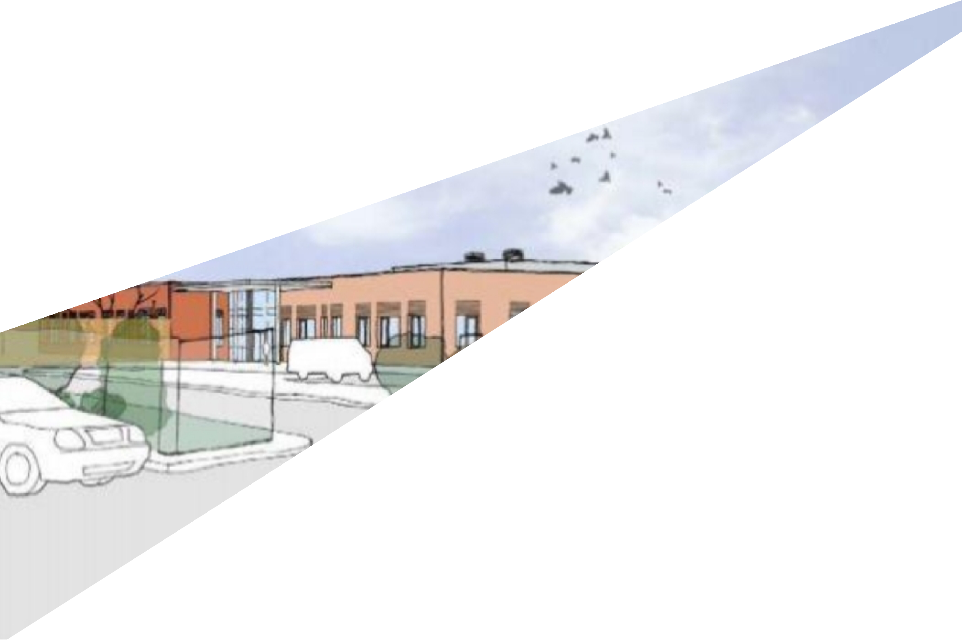
Chatten Free School

Head of School: | Adam Dean
Approved by: | Head of School – LGB aware
Approved Date: | 15/11/23

Contents
Aims 2
Statutory requirements 2
Definition 3
Curriculum 3
Roles and responsibilities 4
Monitoring arrangements 5

Aims
The aims of relationships and sex education (RSE) at our school is to:
Take into account age, maturity, needs and ability to enable our pupils to better understand the nature of human relationships and to develop skills to form friendships and personal relationships.
To prepare pupils for changes which occur in their bodies, minds and emotions as they grow.
- Focus on building Healthy Relationships
- Know that families are important for children growing up, families sometimes look different from their family, respect differences in families
- Know that stable, caring relationships of different types are at the heart of happy families and that marriage represents a formal legal commitment between two people
- Help pupils develop feelings of self-respect, confidence and empathy
- Teach pupils the correct vocabulary to describe themselves and their bodies
- Help pupils understand the importance of health and hygiene
- Prepare pupils for puberty and ensure an understanding of sexual development
- Create a positive culture around issues of sexuality and relationships
- Promote strategies to keep pupils safe
The way extent and way in which RSE is delivered will be specific to individual pupils and address their immediate and ongoing needs in line with our Chatten Free School curriculum policy.

Statutory requirements
From September 2020, all schools must deliver relationships education in primary schools and relationships and sex education in secondary school. The right to withdraw from RSE remains for aspects of sex education which are not part of the science curriculum.
The RSE policy supports the following policies, these documents inform the schools RSE policy:
- Education Act (1996)
- Learning and Skills Act (2000)
- Education and Inspections Act (2006)
- Equality Act (2010)
- Supplementary Guidance SRE for the 21st Century (2014)
- Keeping children safe in education – Statutory safeguarding guidance (2016)
- Children and Social Work Act (2017)

Definition
Relationship and Sex Education (RSE) for our pupils is to help them to understand their emotional and physical development and enable them to make positive decisions in their lives so that they can lead a meaningful, enjoyable and independent life.
At Chatten Free School we understand the uniqueness of our pupils, RSE provision will be appropriate to the individual needs of pupils, taking specialist advice where necessary and in line with the Chatten Free School curriculum document.
- RSE is about the emotional, social and cultural development of pupils, and involves learning about relationships, sexual health, sexuality, healthy lifestyles, diversity and personal identity.
- RSE involves a combination of sharing information and exploring issues and values.
- RSE is not about the promotion of sexual activity.

Curriculum
Pupils at Chatten Free School are taught an entirely individualised curriculum based on their individual needs and understanding. As such we do not have a prescribed scheme of work for our pupils as this might lead to us teaching pupils things that they are unable to process or would not benefit from. Alternatively, a prescribed curriculum could lead to a lack of teaching of skills that are directly and imminently needed for the pupil. Some examples of topics/skills that might be covered that would come under RSE include (but are in no way limited to):
Families | • | Supporting communication basic needs and wants in the family
 | • | Directly supporting families to understand the needs of their child
 | • | Supporting challenging behaviour in the home to improve family life
 | • | Learning to say no to things they do not want/enjoy
 | • | Accessing the community with families
 | • | Labelling family members using pupil’s method of communication
Respectful relationships, including friendships | - Interacting with peers (may be simply tolerating presence of peers)  - Staff will demonstrate an inclusive attitude toward all genders, sexual identities, races, disabilities and sexual preferences. This will provide a positive example of pupils.  - Working on communication, social skills and challenging behaviour in school and the community  - Understanding they can say ‘no’ to things they are not comfortable with.
Online and media | - Pupils who can access computers independently and understand e-safety will be given support on this topic  - Parents will be offered support in the use of online safety tools to prevent their children accessing inappropriate content.
Being safe | Children may not be able to be taught ‘stranger danger’ directly but they can be supported to:  - Not approach people they do not know  - What level of physical contact is appropriate for different acquaintances?  - Walking near a caregiver in the community and not eloping
Intimate and sexual relationships, including sexual health | - For pupils who engage in inappropriate sexualised behaviour this will be addressed directly and as a priority.  - Pupils who engage in masturbation at inappropriate times or in inappropriate locations this will be addressed directly and as a priority.  - Pupils will be taught in more detail around this topic if it is accessible and appropriate for them as an individual.
NB: the above is based on the 2020 DfE guidance of RSE.

Roles and responsibilities
Trustees and LGB
The governing board will approve the RSE policy and LGB will be made aware.
Head of School
The Head of School is responsible for ensuring that RSE is taught in an appropriate way and at an appropriate level for pupils across the school.
Staff are responsible for:

- Communicating with parents and caregivers around RSE
- Delivering RSE in a sensitive way
- Modelling positive attitudes to RSE
- Monitoring progress
- Responding to the needs of individual pupils
We are committed to working with parents and carers, a copy of the RSE Policy will be available on the website, parents will be notified using school coms. We work closely with parents to ensure they are fully aware of what is being taught, they will be informed by letter when RSE is being taught to their son/daughter. They will have opportunities to view materials and resources being used.
Parents have the right to withdraw their child from RSE with the exception of the biological aspects included in the national curriculum Science, up to and until 3 terms before the child turns 16. After this point, if the child wishes to receive sex education rather than being withdrawn, the school will arrange this.
Requests for withdrawal should be put in writing using the form and submitted to the head teacher. A copy of withdrawal requests will be placed in the pupil’s educational record. The Head Teacher will discuss the request with parents and take appropriate action.
Alternative work/activities will be given to pupils who are withdrawn from sex education.

Monitoring arrangements
The delivery, provision and content of RSE is monitored by teachers, phase leaders and SLT.
Resources are monitored with each cohort taught to ensure appropriate materials are available to suit pupil’s ability, learning styles and level of maturity.
Individual progress may be recorded by the teacher as part of their planning and evaluation procedures and will be linked into a student’s Annual Review Key Objectives/Progress grids where appropriate.
The policy will be reviewed yearly and approved by the governors and the Head Teacher

